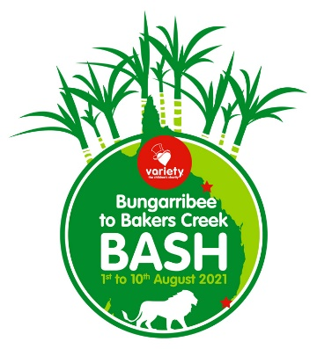
2022 Variety Brydens Lawyers
Bungarribee to Bakers Creek Bash
Raising funds for Variety – the Children’s Charity

Date

Mr Joe Bloggs
Joe Bloggs Electrical Supplies
Bloggs Road
Bloggsville NSW xxxx

Hi Name
This year I am participating in the Variety B to B Bash, Variety’s largest fundraising event. We are all really excited about the opportunity to make a difference and raise much needed funds for kids in need. Variety – the Children’s Charity is a wonderful organisation committed to empowering Australian children who are sick, disadvantaged or living with special needs to have a fair go!
We aim to raise (enter target) for Variety and would be grateful if you would consider donating (you may have different amounts to ask from different donors,e.g. $500) towards this goal but don’t be shy, every little bit counts!
You can donate through our online fundraising page. It’s really easy to donate and you get a tax deductible receipt emailed straight to you. Just go to the link below to go to our fundraising page:
https://fundraise.varietynswact.org.au/fundraisers/CarXXXX
Should you prefer to donate by another method or require an Intention to Donate (like an invoice) from Variety, please just let me know. Thanks so much in advance for your support!

Your donation will help children like 10 year old Yash who has a rare genetic disorder and is unable to speak or walk far by himself. His family turned to Variety to provide a wheelchair for their young son to be able to do everyday things like enjoy dinner at the table with his family, go to school and play outside with his brother and dog. His mum says “The new wheelchair enables Yash to go for long walks with the family and participate in activities such as going to the shopping centre or museums. Variety also supports Yash’s school in many ways, including purchasing a Sunshine Coach.”
A full background on Variety and their work can be seen on their web site. www.variety.org.au
Thank you in advance for your willingness to help. We’ll be in touch.
Cheers

Name

